17.93: As the liquid is compressed, its volume changes by an amount 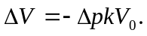 When cooled, the difference between the decrease in volume of the liquid and the decrease in volume of the metal must be this change in volume, or 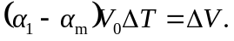 Setting the expressions for 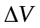 equal and solving for 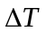 gives
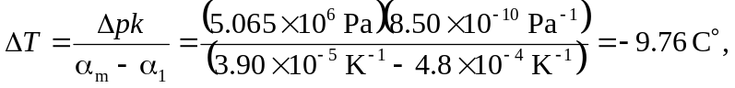
so the temperature is 